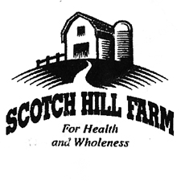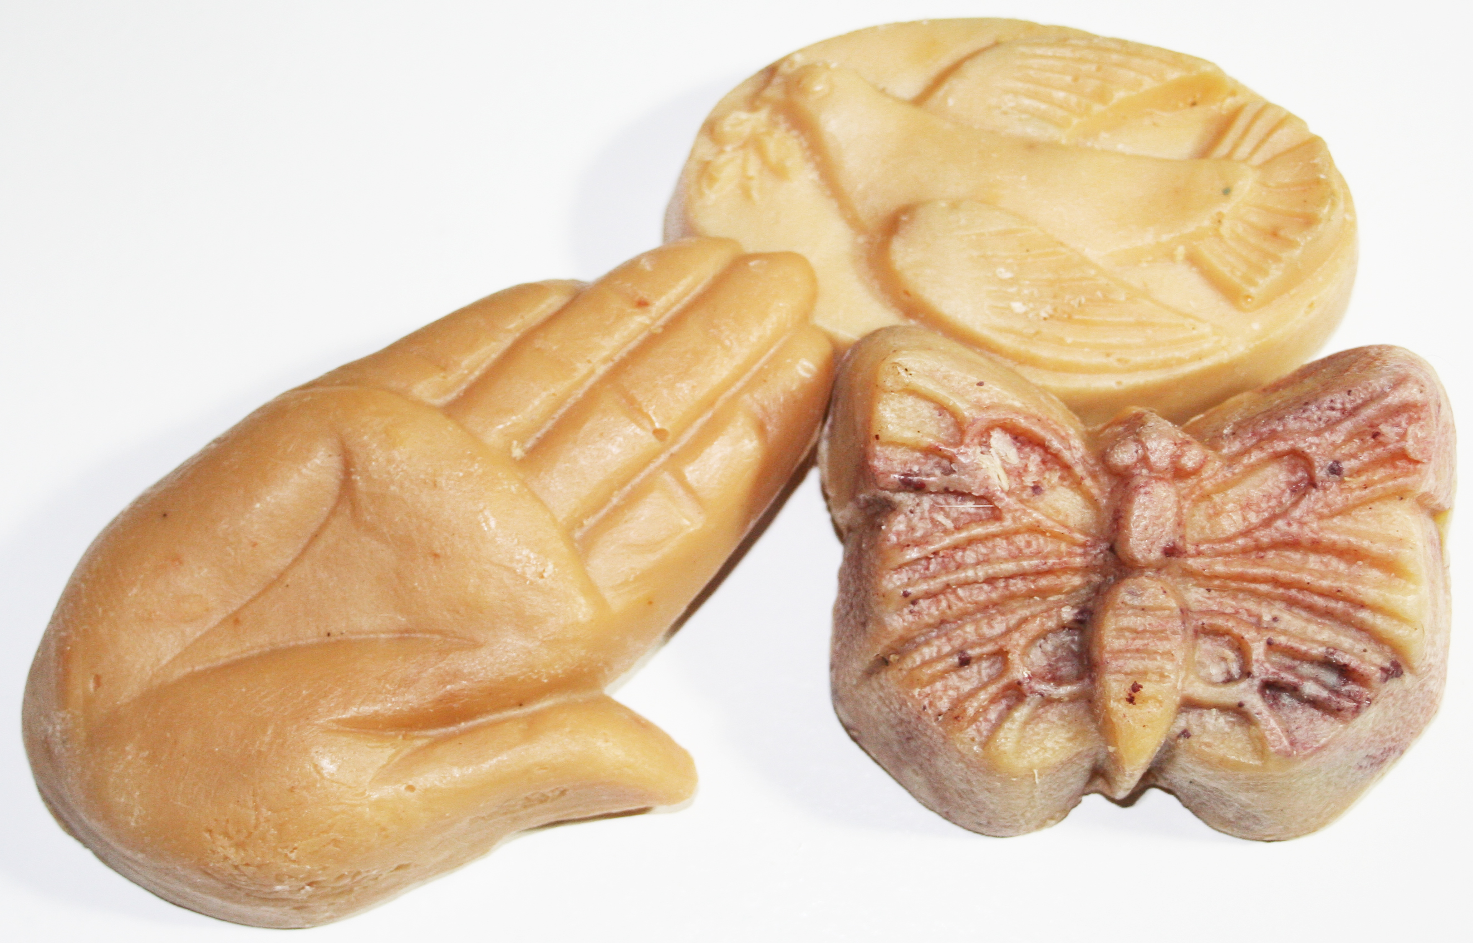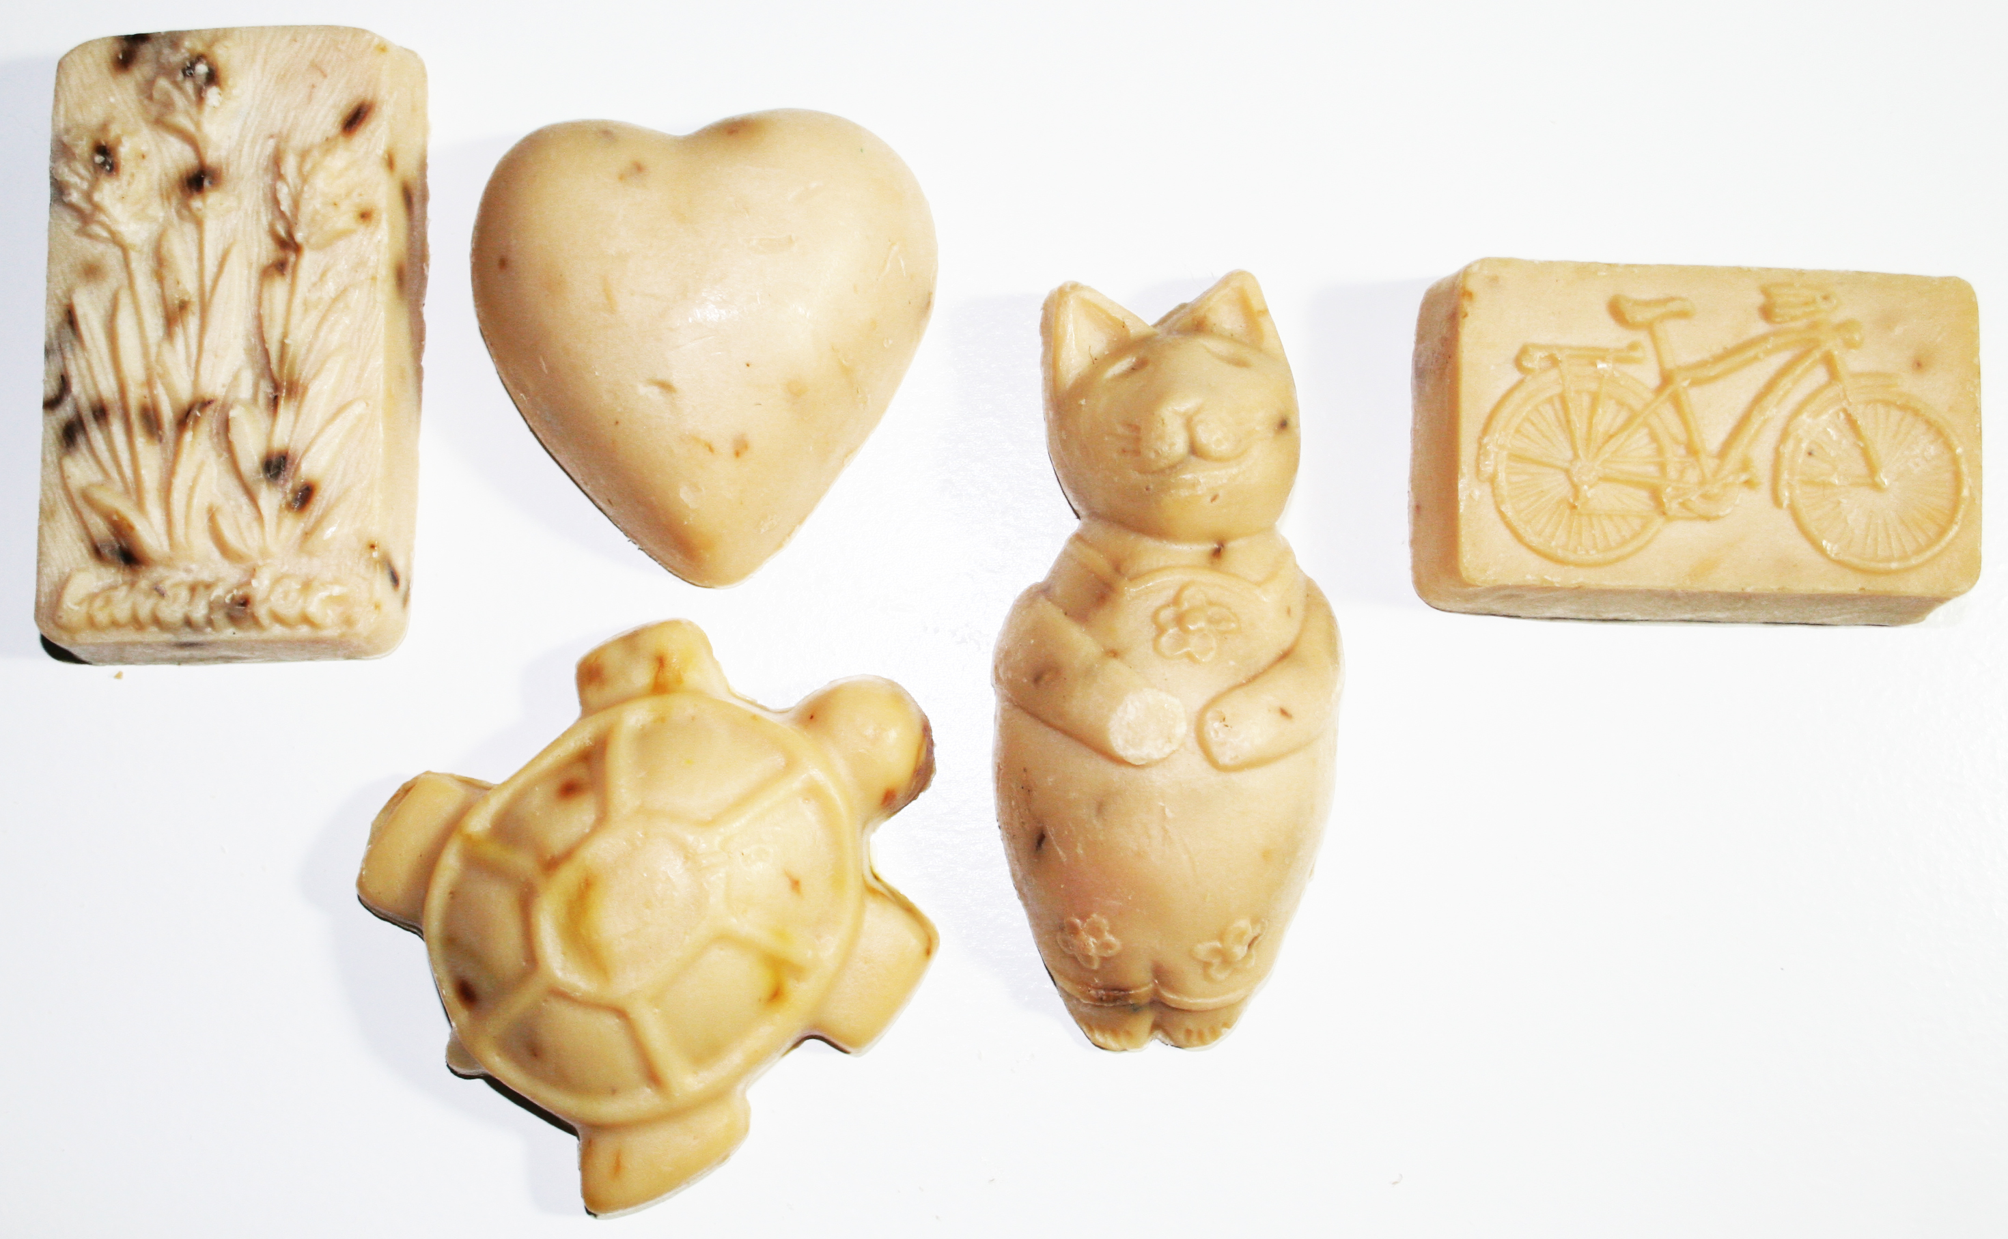

|  |
| --- |
| Our all-natural soap comes in three sizes:  **6-oz -**Bath Bar  **3-oz and 3.5-oz**– Assorted Shapes |

***Scotch Hill Farm’s soap is handcrafted & our Goat Milk is a key ingredient.***

Milk has been used to moisturize skin for thousands of years, and our customers praise the gentle quality

it gives our soap. Goat milk soap is creamy, mild, and 100% All-Natural. Our goats are hand raised on

our small family farm here in Wisconsin, are fed an Organic diet, and we use their milk for our

handcrafted soaps! The soap made at Scotch Hill is milled with herbs, flowers, essential oils, and other

natural fragrances. Milling allows the soap to be gentler on skin and last longer,

all while maintaining the maximum benefits of the essential oils.

We have been growing and selling Organic vegetables and herbs

direct market since 1994,and making soap since 1998.

Scotch Hill is committed to farming in ways that:

Sustain the Earth, Safeguard Soil Fertility and Protects Water Quality.

*We handcraft our soap with the same care and concern for you.*

**PRODUCTS**

**Lip Balm**

**2-oz Lotion Butter:** shea butter, sweet almond oil, and essential oils

**3.5-oz Shaving Soap Bar:** coconut oil, kaolin, tea tree and mint.

**2-oz tube Deodorant:** made with 100% natural ingredients

**4-oz Shower Scrub:** coconut oil, salt, sugar, and essential oils.

**All Natural Insect Repellent:** contains Neem and other essential oils.

**Dog Shampoo Bar**: Our farm dogs put these soaps to the test!

This soap will keep your pet smelling great, feeling soft, and silky.

No more scratching from conventional soaps that damage skin.

Contains essential oils, including Neem to repel bugs.

|  |
| --- |
| **SCENTS**  **Pure/Unscented**: for sensitive skin  **Lavender**: a calming flower  **Honey Oat**: moisturizing exfoliate  **Vanilla**  **Rosemary Mint**  **Lemongrass**  **Patchouli**: a calming herb from the far East  **Cedar and Saffron**  **Lily of the Valley**  **Tea Tree with Comfrey**: a natural antiseptic oil for mild rashes and skin irritations. Excellent for facial cleansing. |

|  |
| --- |
| **Dela Ends / 910 Scotch Hill Road Brodhead, WI 53520**  **608-897-4288 / dela@scotchhillfarm.com www.scotchhillfarm.com / Facebook: Scotch Hill Farm** |

**Soap at Scotch Hill is handcrafted & our Goat Milk is a key ingredient.**

Milk has been used to moisturize skin for thousands of years, and our customers praise the

gentle quality it gives our soap. Goat milk soap is creamy, mild, and 100% All-Natural.

These goats are hand raised on our small family farm in Wisconsin, are fed an Organic diet,

and their milk is used for our handcrafted soaps!

It is then milled and scented with herbs, flowers, essential oils, and other natural fragrances.

Milling allows the soap to be gentler on skin and last longer,

all while maintaining the maximum benefit of the essential oils.

We have been growing and selling Organic vegetables and herbs

direct market since 1994 and making soap since 1998.

**Scotch Hill has been committed to farming in a way that:**

**Sustains the Earth, Safeguards Soil Fertility and Protects Water Quality.**

***We handcraft our soap with the same care and concern for you.***